
COLLEGE CODE: 8219
COLLEGE NAME: ST.JOSEPH’S COLLEGE OF ENGINEERING AND TECHNOLOGY
DEPARTMENT: ARTIFICIAL INTELLIGENCE AND DATA SCIENCE
DATE: 01.10.2026
CREDIT COURSE: Salesforce Developer - NM Eng
PROJECT TITLE: WhatNext Vision Motors: Shaping the Future of Mobility with Innovation and Excellence
SUBMITTED BY,
TEAM LEAD:
AFRA M - 821923243004
B99B4EE3B6D3A238709493EA84AD9C67
TEAM MEMBERS:
ABINAYA V - 821923243003
01437221EFBA23EA9BD42C4D29481252
JELINA G - 821923243022
B020E11899693CEB6AA4A7EE418D649E
SANTHIYA P - 821923243045
B00F4F71D14695DBC9149A004FBE0A24
WhatNext Vision Motors: Shaping the Future of Mobility with Innovation and Excellence
STEP 1: USER SCENARIO
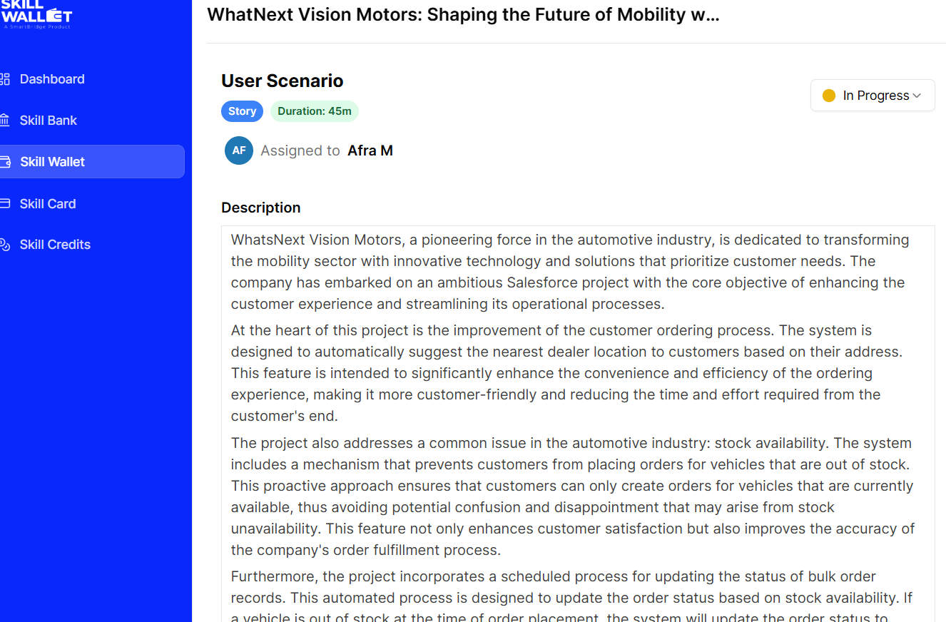
STEP 2: Developer Account Creation
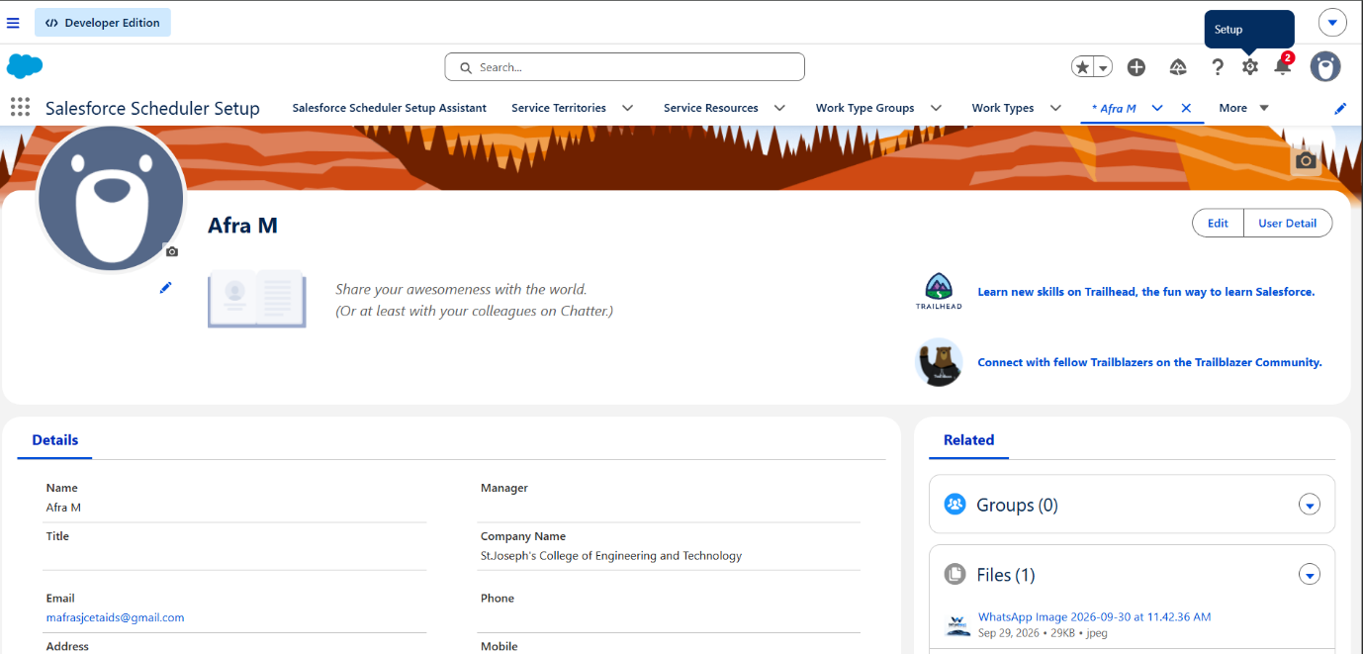
STEP 3: Verify Account
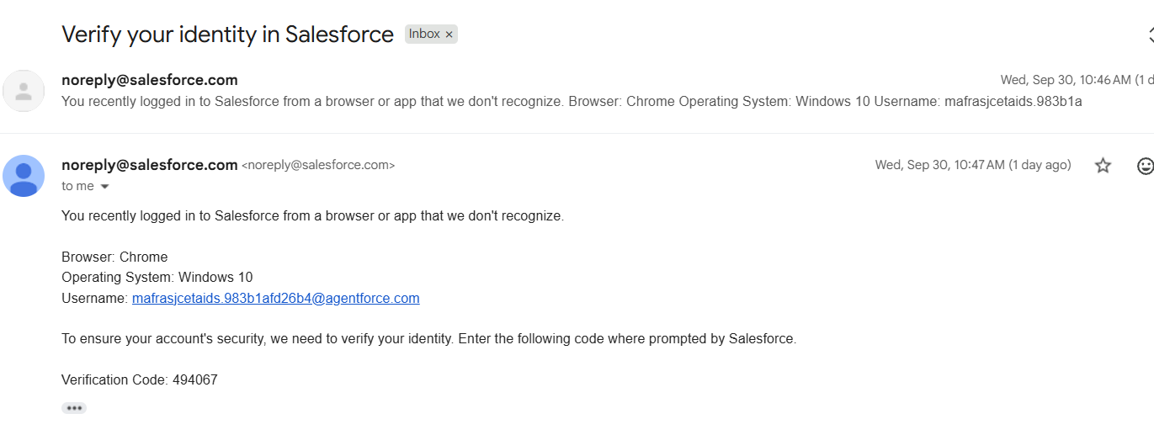
STEP 4: Data Management-Objects
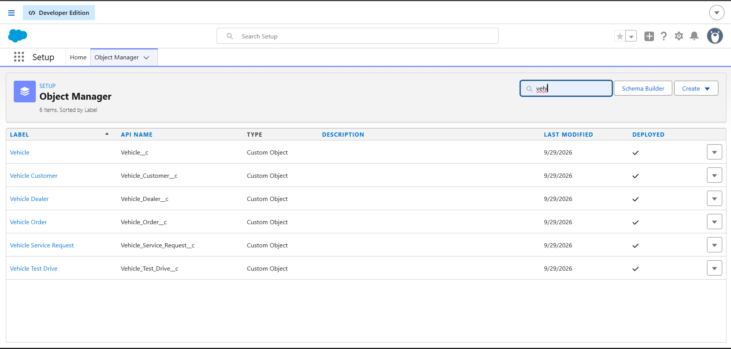
STEP 5: Lightning App Creation
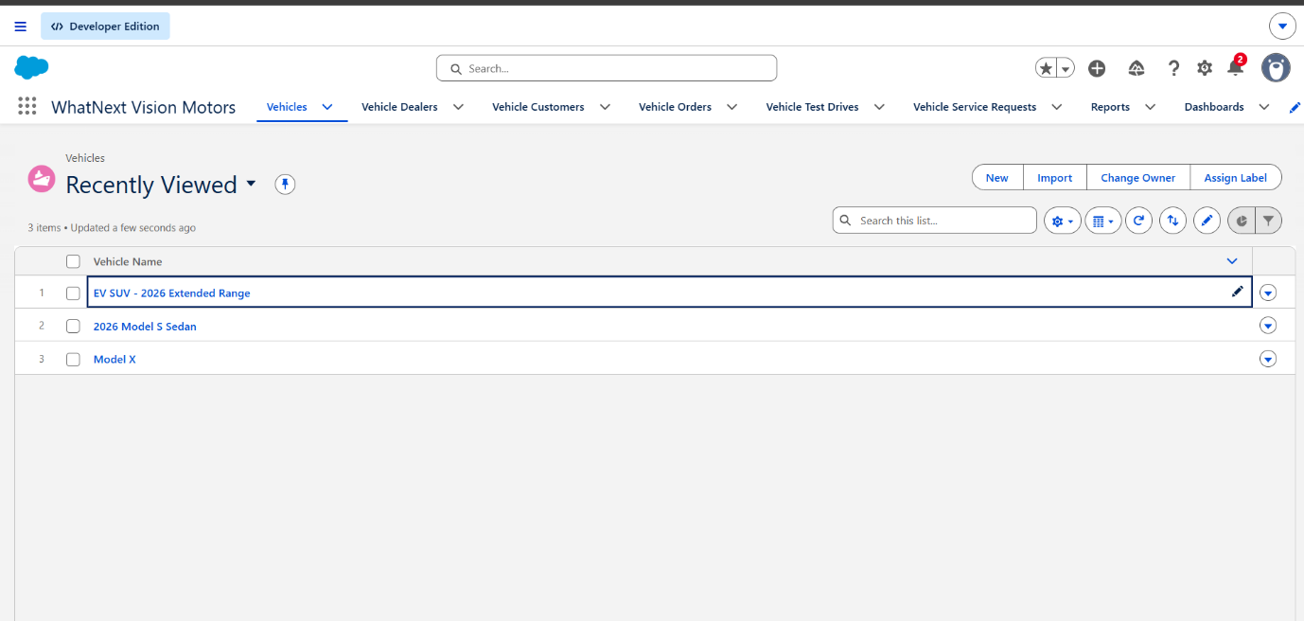

STEP 6: Data Management-Fields
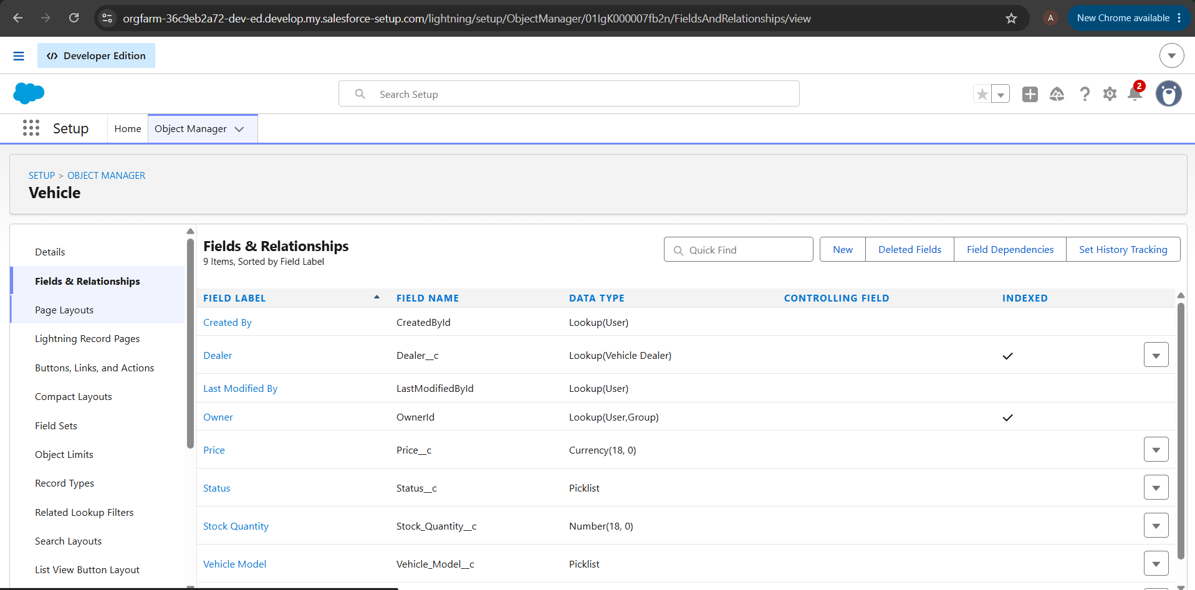
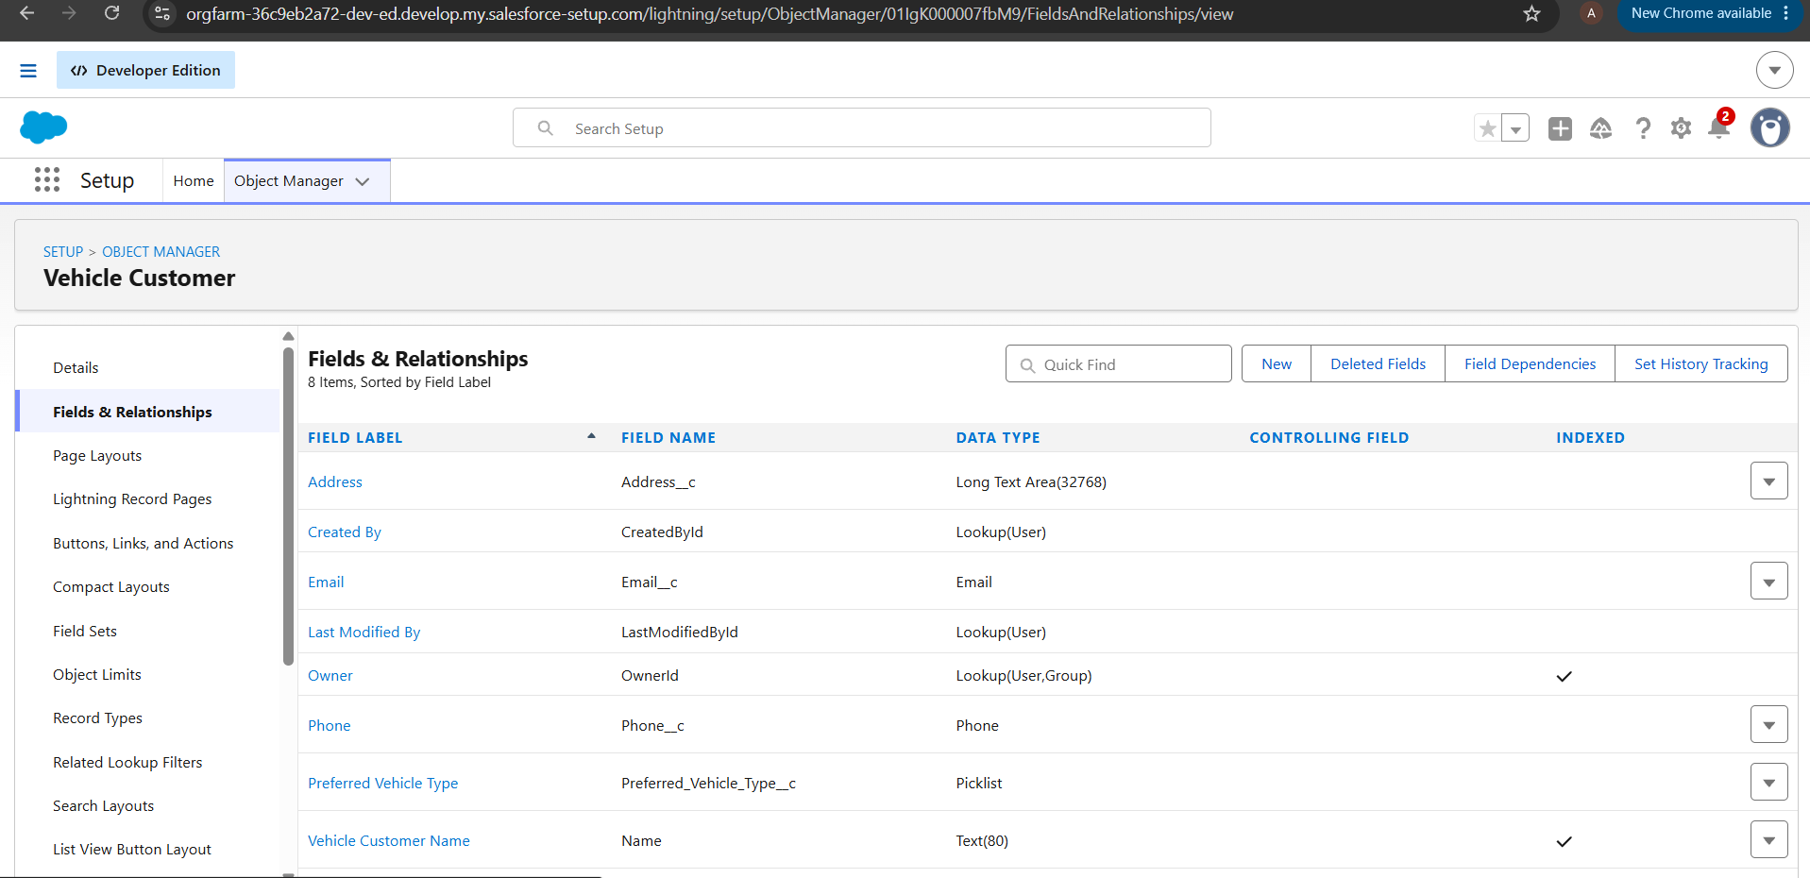
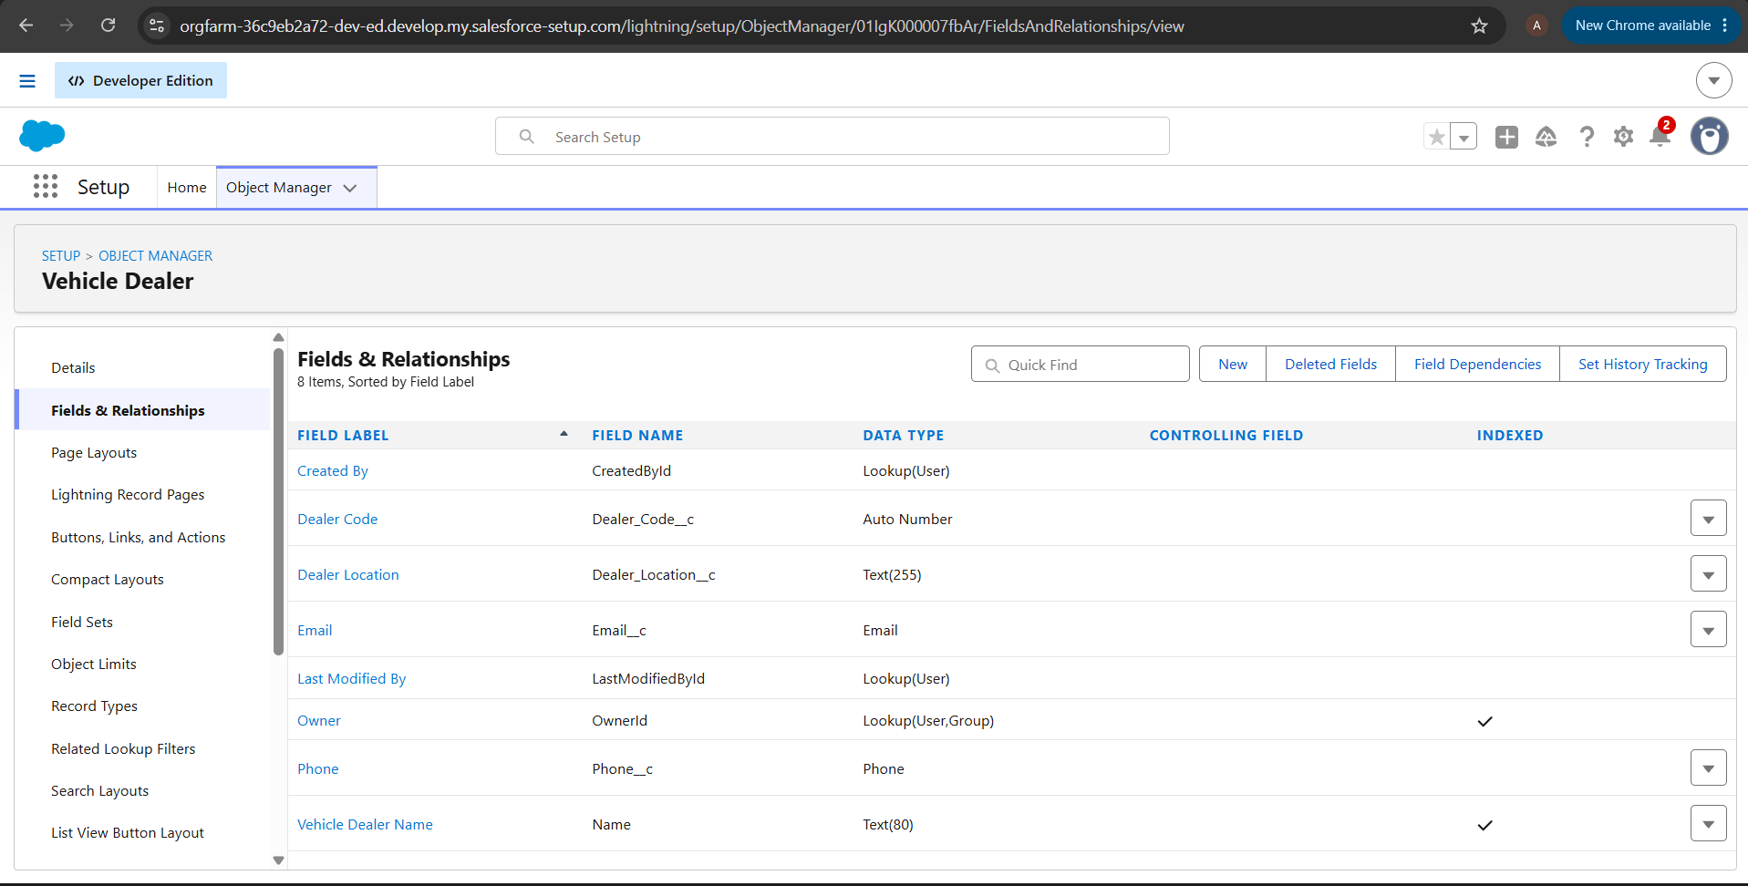
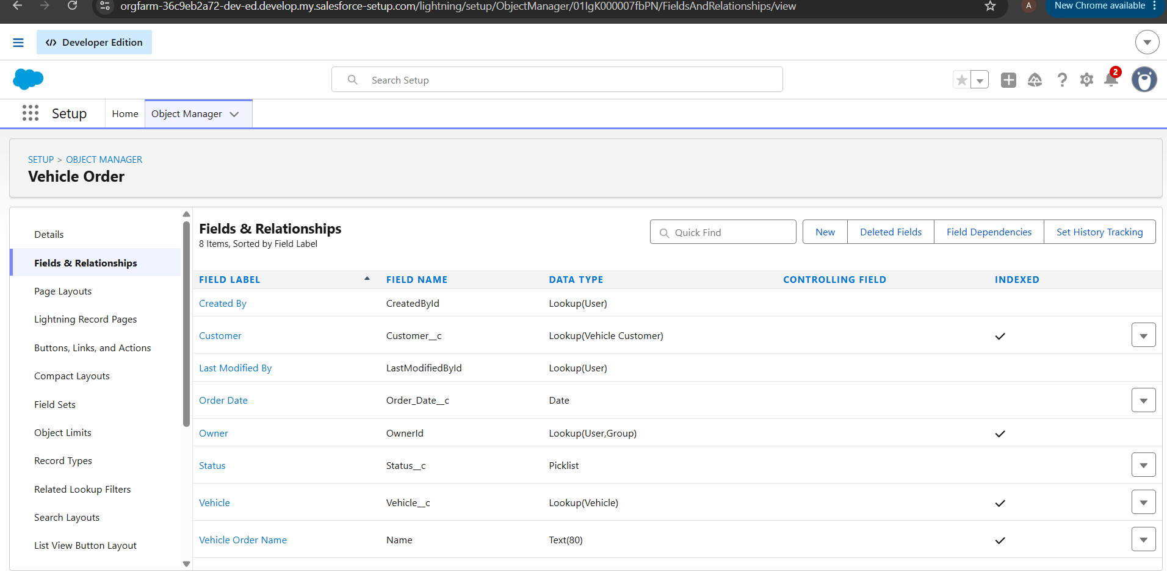
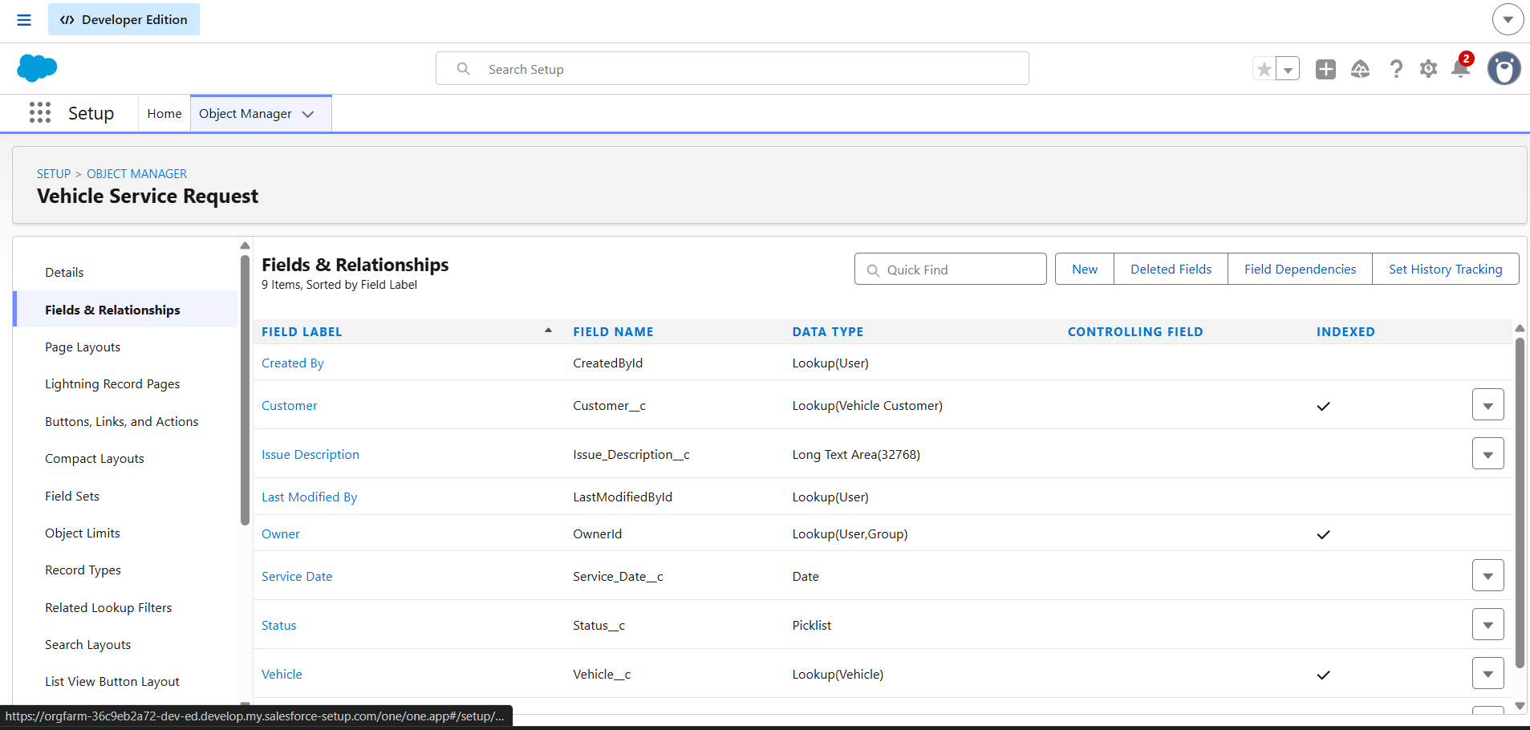
STEP 7: Automation
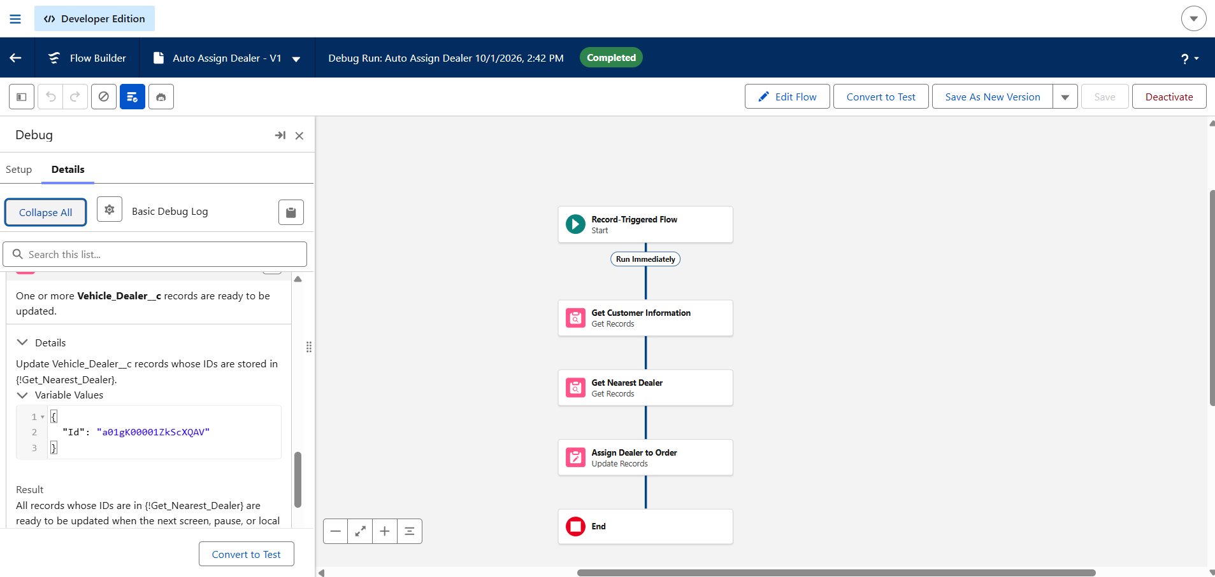
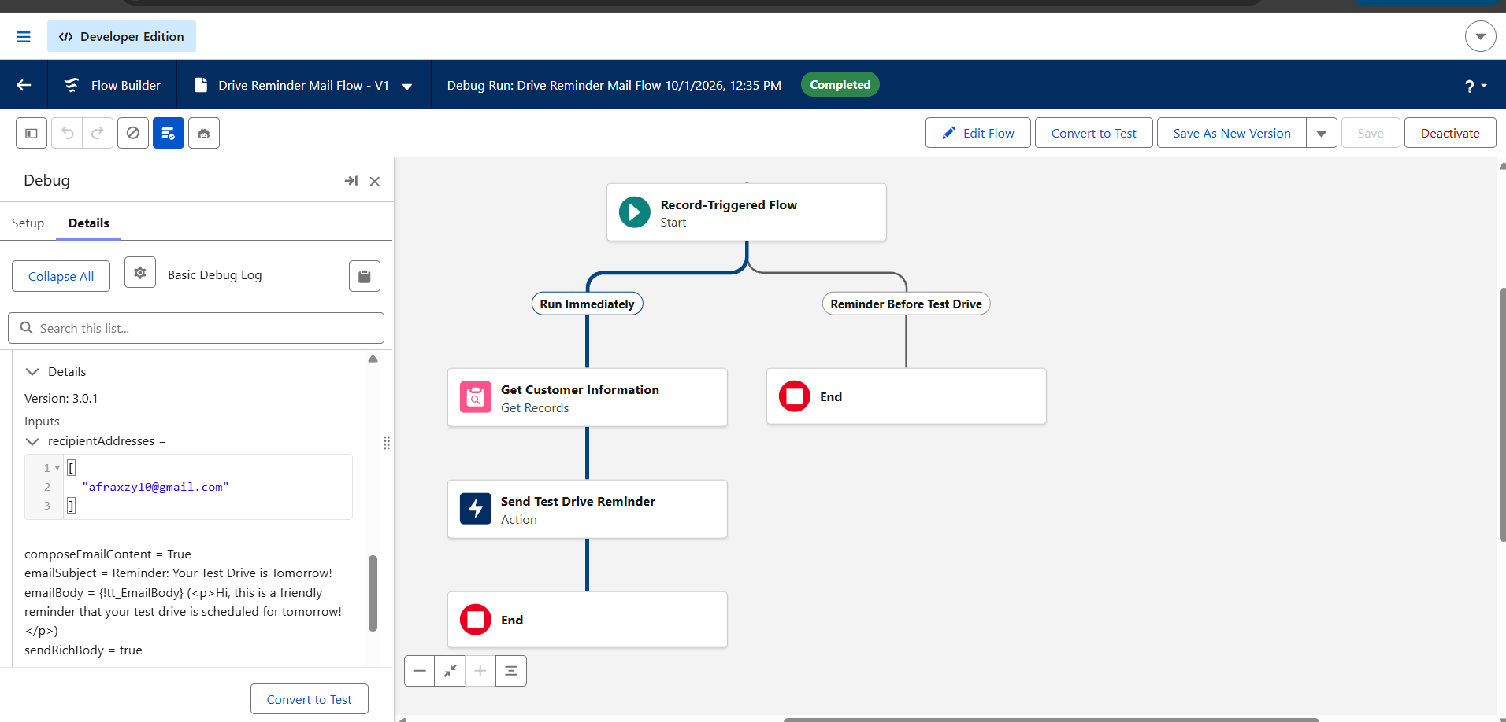

STEP 8: Apex and Batch Class
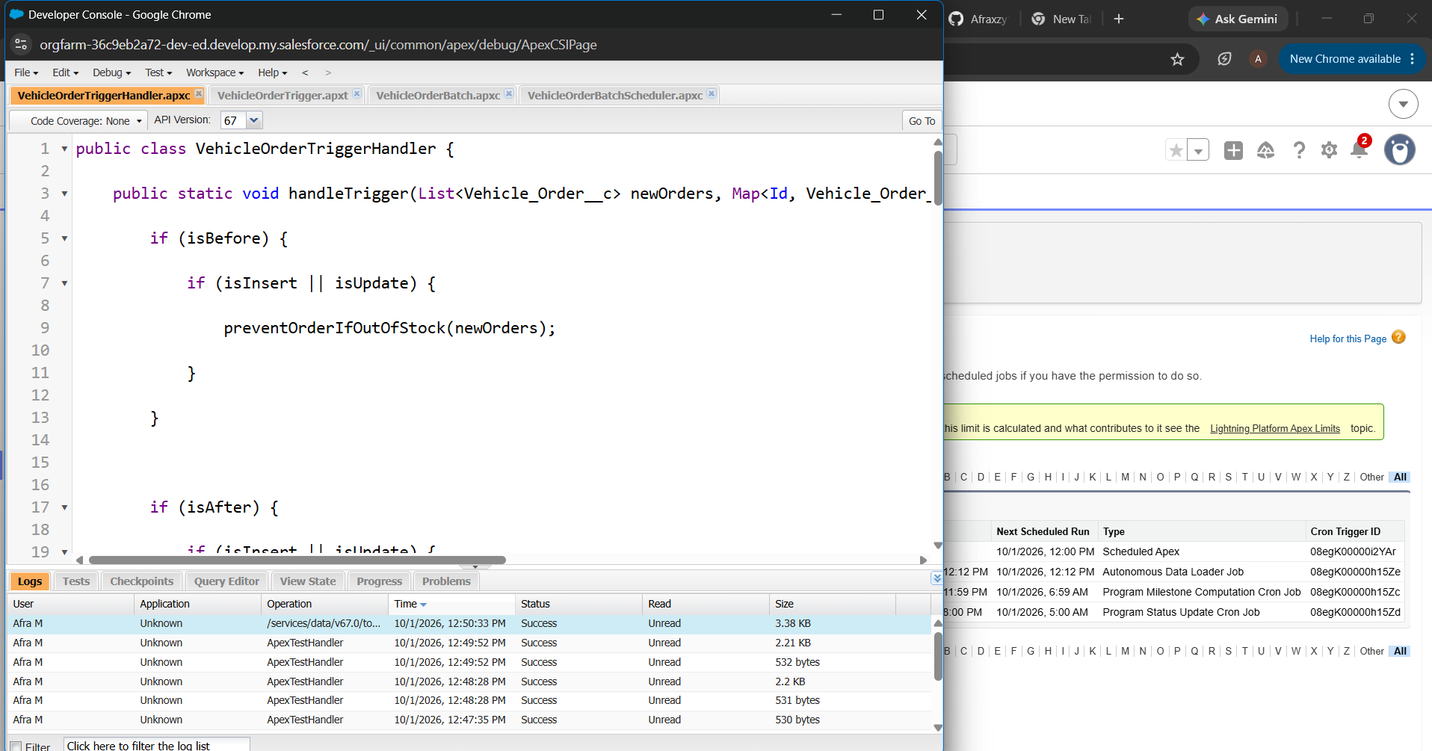
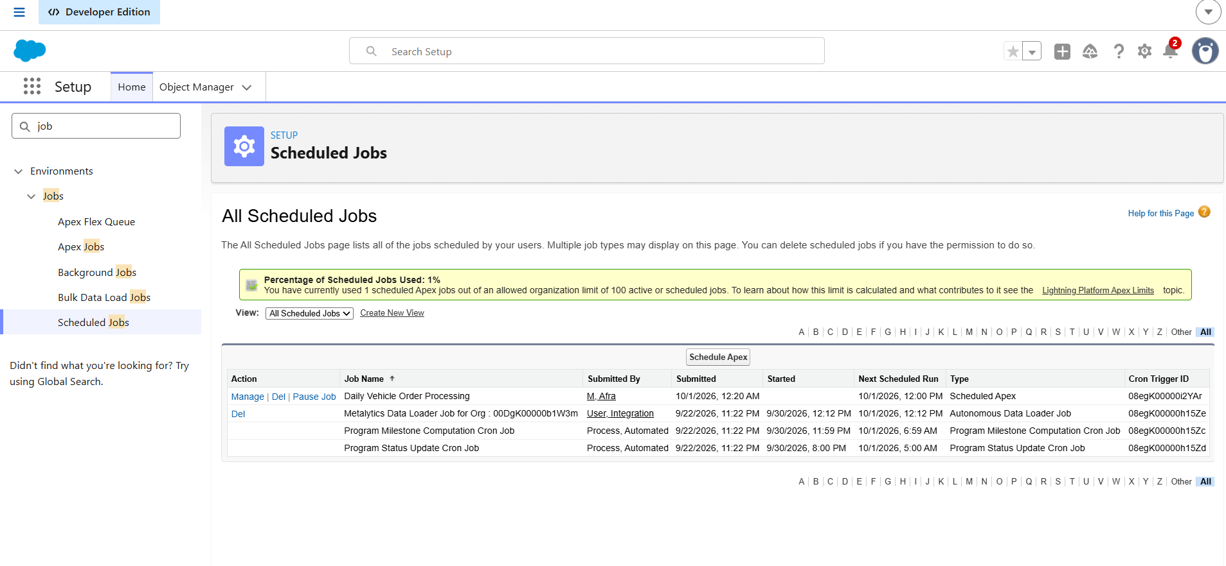
Demo Link for Step 7 & Step 8 :
https://drive.google.com/drive/u/0/folders/1cGsmtglcclFkLsscfpsolGfvlK_StfAB

